Use Case Template

Version 1.0
By Debug Entity
SSN College of Engineering

Revision History
Date | Author | Description of change
NIL

USE CASE ID | CONTRIBUTORS
UC 1, UCD | V SAI SRIYA
UC 2 | MOHAMMED RIYAS
UC 3 | R SAI PRAKASH
UC 4 | SANGAMITHRA S
Use Case: Login Portal

Id: UC- 1

Description
The user is asked to login to their account by providing their username and password. If the user doesn’t have an account, they are allowed to create one.

Level: High

Primary Actor
- Admins
- Customers
Supporting Actors
- Database Managers

Stakeholders and Interests
- Database Managers – Verifies whether all the details are proper or not.

Pre-Conditions
- Stable internet connection is provided
- User has valid email id and phone number

Post Conditions
Success end condition
- User is logged in
- Account created
- Admins taken to admin page
- Customers taken to homepage

Failure end condition:
- User isn’t logged in
- Account not created

Minimal Guarantee
- Users view their respective homepages

Trigger
- User enters username and password

Main Success Scenario
- User is asked to enter username and password to proceed
- User enters the details
- The system verifies the details
- The user is redirected to the homepage
- The above steps will happen if and only if the user already has an account if not user should create an account.

Extensions
- If the user doesn’t have an account
- They can select the create new account.
- The user will then be required to fill in details such as name, email id, phone number, address and create a password.
- Once they do all that is necessary an account on their name will be created.
- If the user has forgotten their password at the time of login
- They can click the forgot password button
- An OTP will be generated to their email id using which they can reset their password.

Variations
- To login the user can give their email id as username.

Frequency: Every time the user wants access to the homepage this login usecase will be executed

Assumptions
- Good internet connection
- Fault free server connection

Special Requirements
Performance Requirements
- The website shall process the information within 15 seconds of the user request
Security Requirements
- The system shall display the characters of the password in a masked format when they are entered by the user. Example the characters will be masked and be displayed as ***.
Rationale – This is to ensure that a bystander will not be able to read the password.
- The details of the customers will not be disclosed by the administrators who have access to the details.
User Interface Requirements
- The login page shall display all options and messages in English
- The font of all letters will be Times New Roman with a size of 12.

Issues

- The minimum size of the password should be 8 characters
- All the email ids provided should be unique

To do
- The database for the details of all users needs to be created.
Use Case: Profile Details

Id: UC- 2

Description
The user views their profile details like name, mobile number and email id. They are allowed to change their password as well.

Level: High

Primary Actor
- Customers
Supporting Actors
- Database Managers

Stakeholders and Interests
- Database Managers – Verifies whether all the details are proper or not.

Pre-Conditions
- Stable internet connection is provided
- User has valid email id and phone number

Post Conditions

Success end condition
- Details get displayed
- Password changed

Failure end condition:
- User doesn’t view their details
- Wrong details displayed
- Password is not changed

Minimal Guarantee
- Users view details

Trigger
- User clicks view profile on their homepage

Main Success Scenario
- The user clicks view profile on homepage
- The profile details are generated.
- On the bottom of the page the option to change the password i

Extensions

- If the user wants to change the password
- They can click the change password button
- They should enter their new password and confirm that password and proceed

Variations
- The user is allowed to change the password only once in two weeks

Frequency: Every time the user wants to view their details

Assumptions
- Good internet connection
- Fault free server connection

Special Requirements
Performance Requirements
- The website shall process the information within 15 seconds of the user request
Security Requirements
- The system shall display the characters of the password in a masked format when they are entered by the user. Example the characters will be masked and be displayed as ***.
Rationale – This is to ensure that a bystander will not be able to read the password.
- The details of the customers will not be disclosed by the administrators who have access to the details.
User Interface Requirements
- The profile details shall be displayed in English
- The font of all letters will be Times New Roman with a size of 12.

Issues
1.The minimum size of the password should be 8 characters

To do
- The database for the details of all users’ needs to be created.

Use Case: Admin page

Id: UC-3

Description
The Admin is able to add, delete or update the items in the catalog. The Admin is also able to update the status of the existing orders, and also able to view the history of all the orders.

Level: High

Primary Actor
Admin

Supporting Actors
Customers

Stakeholders and Interests
Database Managers – Verifies whether all the details are proper or not

Pre-Conditions
- Stable internet connection is provided.

Post Conditions

Success end condition
- Able to add, delete or update items in the catalog
- Check history of orders
- Update status of orders

Failure end condition:
- Unable to add, delete or update items in the catalog
- History of orders cannot be viewed
- Status of orders cannot be updated

Minimal Guarantee
The admin will be able to update the items in catalog.

Trigger
When admin enters admin username and password in login module

Main Success Scenario
- The Admin is able to view the catalog.
- The Admin can add, delete or update the items in the catalog.
- The status of the existing orders can be updated by the Admin.
- The Admin can view the history of the orders.

Variations
- Then admin may add or delete items with the item code or select from database

Frequency: The Admin page will be opened whenever the Admin logs in.

Assumptions
- Good internet connection
- Fault free server connection

Special Requirements
Performance Requirements
- The website shall process the information within 15 seconds of the user request
Security Requirements
- Status and history of the orders contain details about the customer and will not be disclosed by the administrator.
User Interface Requirements
- The catalog shall display all the items in English.
- The font of all letters will be Times New Roman with a size of 12.

Issues
- An item can be added only once, i.e. the same item cannot be added again. It can be deleted or updated.

To do

- The database for all the details of the orders needs to be created.
- The database with the details of the items needs to be created.
Use Case: View products

Id: UC- 4.1

Description
Allows the customer to search the products and view the products and add the required products to shopping cart.

Level: sub function

Primary Actor
- Customer

Supporting Actors
None

Stakeholders and Interests
- Product provider –has interest in providing bulk quantity of products to the merchant.

Pre-Conditions
- User must log onto the system before this use case begins

Post Conditions

Success end condition
User selects their required category and views the product and successfully add their required products to the shopping cart.

Failure end condition:
After looking at all the details of the products, the user failed to add the product to the cart.

Minimal Guarantee
- No products will be added to the shopping cart without user’s knowledge
- Gets a confirmation from the user while adding the products to the cart

Trigger
- User should select their required category, size, material, brand before adding to the cart.

Main Success Scenario
- User logs onto the website.
- User selects their desired category, size, material.
- User adds the product to the cart.

Extensions
- If the user does not like a particular color, user can choose the option color and can choose their required color.
- If the user does not like the particular size, user can use the size filter and can refer to the size chart given for reference.
- If the user does not like a particular material, they can change the material type given from the options provided.

Variations
- Display can be changed to dark or white theme based on user’s wish.

Frequency:
Available all day and user can access any number of times.

Assumptions
- Good and proper display of products
- Easy graphical user interface

Special Requirements

Performance Requirements
- All the details in the catalogue will be visualized in a responsive web page format ,
So, the user can view the website in laptop or in mobile
Security Requirements
- Products will not be added without user’s knowledge.
User Interface Requirements
- All the products will be displayed with their pictorial format and a small description is give beneath to help the customer understand more about the product.
- The font of all the product details will be Times New Roman with a size of 10.

Issues
- User should have stable internet connection

To do
- Make database containing product details.

Use Case: Confirming order

Id: UC- 4.2

Description
This use case shows the list of products selected by the user and the total amount for all the products selected by the user will be displayed. Here the user can delete the product and a confirmation from the user is got for all the products in the cart

Level: user goals

Primary Actor
- user

Supporting Actors
None

Stakeholders and Interests
None

Pre-Conditions
- The user has logged onto the website and has place the products in the cart.

Post Conditions

Success end condition
- The success condition is when user decide to purchase all the products added to the shopping cart.
Failure end condition:
- The failure condition is when user removes any product or reduces the quantity of the product from the selected products in the shopping cart.

Minimal Guarantee
- All the selected products will be stored in the shopping cart.
- Doesn’t confirm the quantity and order confirmation without user’s permission
- The system has logged off

Trigger

- User adds all the desired products to the cart.
- User can increase and decrease the product quantity before confirming the order.

Main Success Scenario
1. User clicks the cart option
2. List of products selected by the user are displayed.
3. User can do modification like increase or decrease the quantity or remove the products from the cart.
4. Total amount is displayed to the user.
5. User confirms his order.

Extensions
- If the user wants to add an extra product, he can be redirected to the home page and the needed products can be added to the cart

Variations
- If the user uses a coupon code there will be a reduction in the total amount and then the user can pay the remaining amount.

Frequency: Every time when user wants the check their items in the cart and confirm their order, this use case will be executed

Assumptions

- Good split of cost details and total amount of display

Special Requirements

Performance Requirements
- Any change in the quantity of the product will affect the total amount in the cart, this change in amount will be processed within a few seconds, mostly less than 10 seconds.
Security Requirements
- The order will not be confirmed without user’s knowledge.
- A double confirmation will be asked to the user about proceeding to payment.
User Interface Requirements
- All the products selected by the user will be shown in properly in an order of increasing product quantity.
- A thumbnail image of all the products is shown so the user gets a good clarity of the products selected by them.
- Split of total amount, ie including service tax, gst, delivery charges are clearly shown to the user.

Issues

- If the user changes the quantity of the product in the cart, the total amount might not have been changed sometimes for that we have to refreshed the page to get the correct total.

To do
- Send a confirmation message to the user for confirming the order
Use Case: placing order

Id: UC- 4.3

Description
In this use case the user selects the payment mode and enter all the necessary details for the required amount and complete their payment process and the user places the order.

Level: high

Primary Actor
- user
Supporting Actors
- Bank
Stakeholders and Interests
- Bank- used as a mediator to transfer money from the customer to merchant.
Pre-Conditions
- The user has logged on to the website and the user has products in the cart and has clicked the checkout button.

Post Conditions

Success end condition
- The user has entered the proper address and details for the shipment and payment and has process an order for their desired product.

Failure end condition:
- User fails to enter the proper details for the payment.
- Transaction is incomplete and no payment is received from the bank side to the owner.
Minimal Guarantee
- The system logs out of the website if the user doesn’t enter the OTP for transaction verification within 20 seconds.

Trigger
- User enters the address for shipment of their products.
- User enter the card details for the payment of their products.

Main Success Scenario
- User confirms the order and redirects to the payment page.
- User first enters the address for shipment.
- User selects the payment mode.
- User enters the card details for payment.
- An opt is sent to the user for verification
- Order is placed to the user.

Extensions

- Ship to different address – when user desires to have their products shipped to a different address than the one, they are registered.
- Invalid data input- when the user fills out the credit card information incorrectly and system tells the user which data is invalid and the user will make the necessary changes to the credit card information.

Variations
- Using different payment method like credit card, Paytm, debit card, google pay and other online transaction.

Frequency: This use case will be executed every time when the user wants to place an order

Assumptions

- No interrupt in between the transaction

Special Requirements

Performance Requirements
- All the redirection in payment process is to be done within 10 seconds, so there exists no confusion in the payment process.
Security Requirements
- OTP and other secure details such as customers name, customers card number, expiry date, cvv are properly are retrieved from the user.
- Any doubt in detail retrieval leads to security concerns so the payment process will be aborted.
User Interface Requirements
- Firstly, the user should select the mode of payment preferred to them.
- Accordingly, the details are obtained from the user.
- After successful completion of payment, the payment details are sent to the user.

Issues
- The card number should not exceed more than 16 characters
- The cvv number should not exceed more than 3 characters.
- The expiry date should not be past date from the present date.
- The name should be in capital format.

To do
- To send an order confirmation mail to the user.

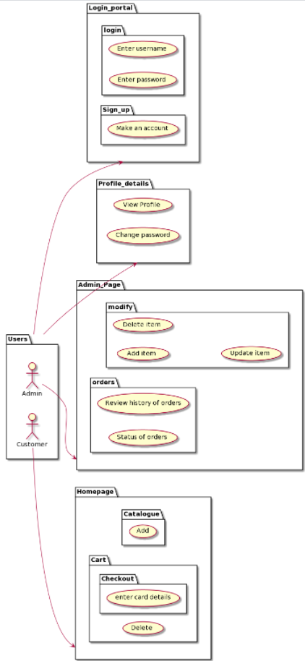
USE
CASE
DIAGRAM

